# MINI PROJECT (2020-21)

**Instagram Clone**

**MID-TERM REPORT**



**Institute of Engineering & Technology**

**Submitted by-**

# Kritarth Sharma (181500335)

# Priyanka Nigam (181500509)

***Supervised By: -* Mr. Amir Khan** Technical Trainer

# Department of Computer Engineering & Applications

**Contents**

|  |  |
| --- | --- |
| **Abstract** | **3** |
| **1. Introduction** | **4** |
| 1.1 General Introduction to the topic | **4** |
| 1.2 Area of Computer Science | **5** |
| 1.3 Hardware and Software Requirements | **6** |
| **2. Problem definition** | **7** |
| **3. Objectives** | **8** |
| 4**. Implementation Details** | **11** |
| **5. Progress till Date & The Remaining work** | **11** |
| **6. Some Screenshots** | **12** |
| **7. References** | **13** |

**Abstract**

In this we will build a a dynamic project siimilar to instagram that has innovative features. We are trying toadd as many features as possible.

A mobile photo(and video) capturing andsharing service, has quickly emerged as a new medium in spotlight in the recent years. It provides users an instantaneous way to capture and share their life moments with friendsthrough a series of (ﬁlter manipulated) pictures and videos.

# Introduction

**1.1 General Introduction to the topic**

The main theme of the project is to build a social media website where the user can do the following things:

* Register if new user
* Login
* View the feeds
* Add posts
* Share the posts
* Comment on posts
* Like the post
* Share photos
* Share Videos
* Send friend request

Admin of the site should have control over:

* Designing and developing the website.
* Creating and updating the database
* Inserting, viewing, updating, deleting the data in the database.

**Software Specification:**

Technology Implemented : Django

Language Used : Python

Database : Mysql

User Interface Design : Html,css , javascript and Bootstrap

Web Browser : Microsoft edge/chrome

**Hardware Requirements:**

Processor : 64-bit

Operating System : Any one (Preferrrably above Windows 8)

RAM : 4-GB

# Objective

The main objectives of Social networking project is to make people connected as much as possible.It is an Indian based web-app hosted on Heroku.

# Home page

# About page

# Admin panel

# Post delete

# Post save

# Registration form sign in/sign upProgress

# SCREENSHOTS

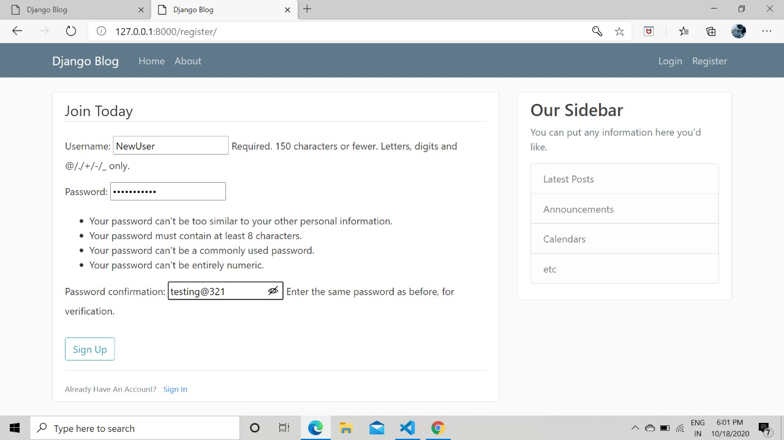

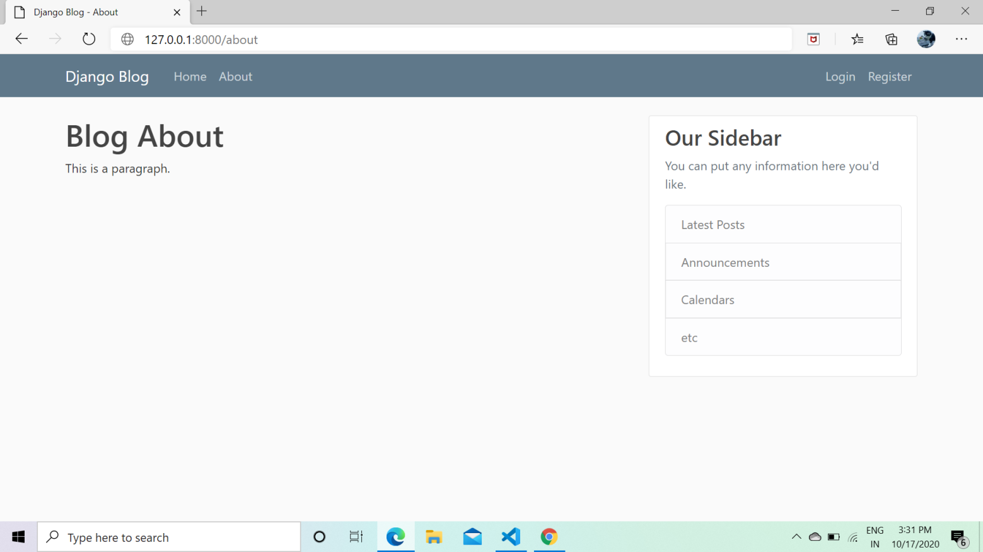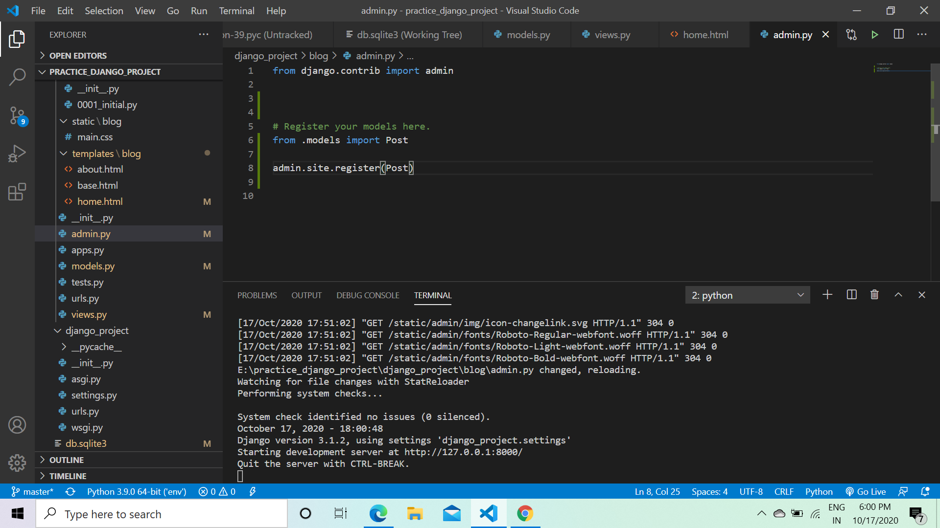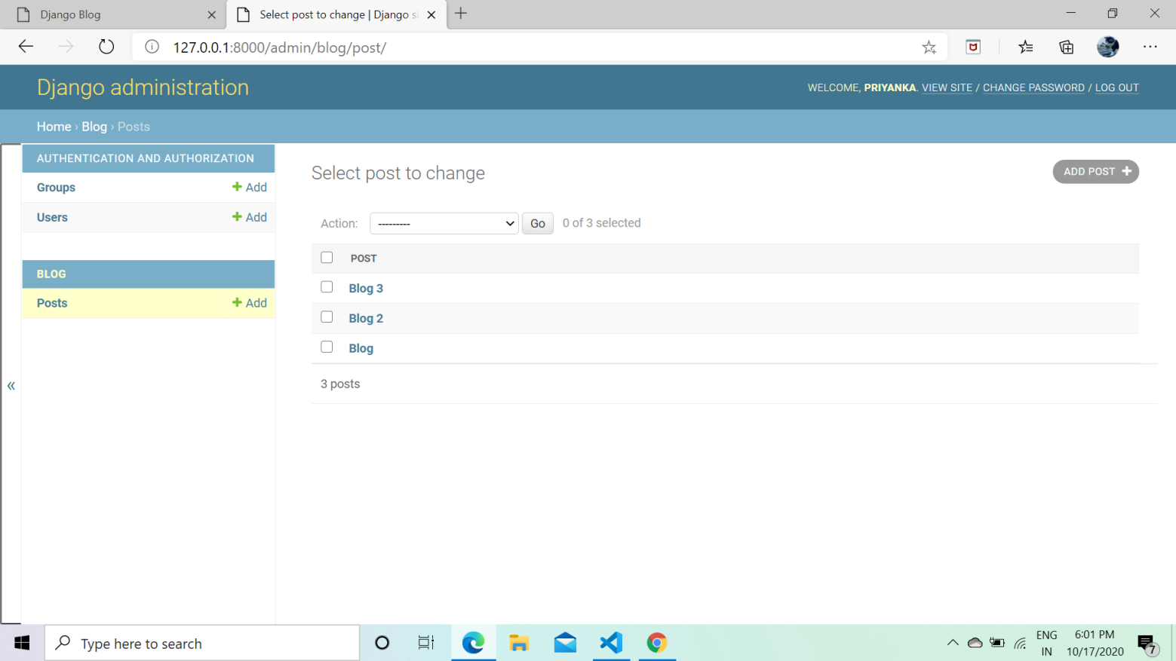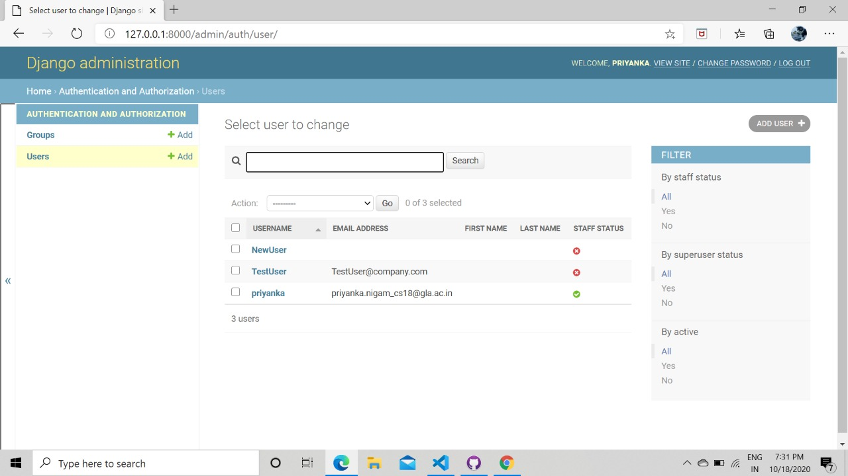

**References**

* + - * <https://kritarthgram.herokuapp.com/>
      * https://instagram.com/